S3 Bucket Assignment

1. **S3 Bucket Creation Assignment**
2. Creating a S3 bucket

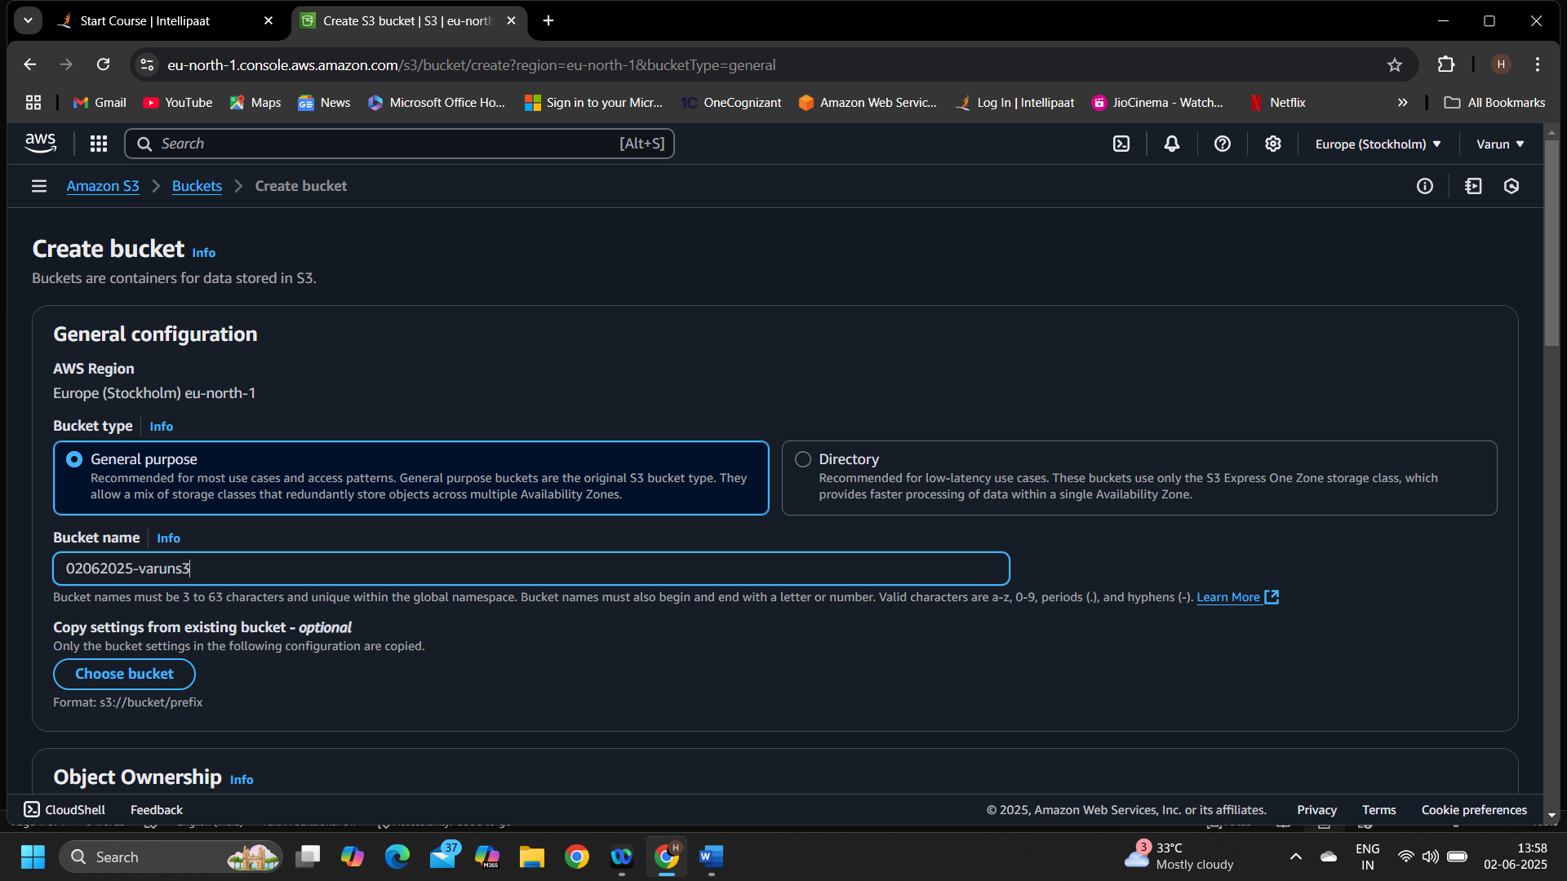

1. Uploading 5 different file types

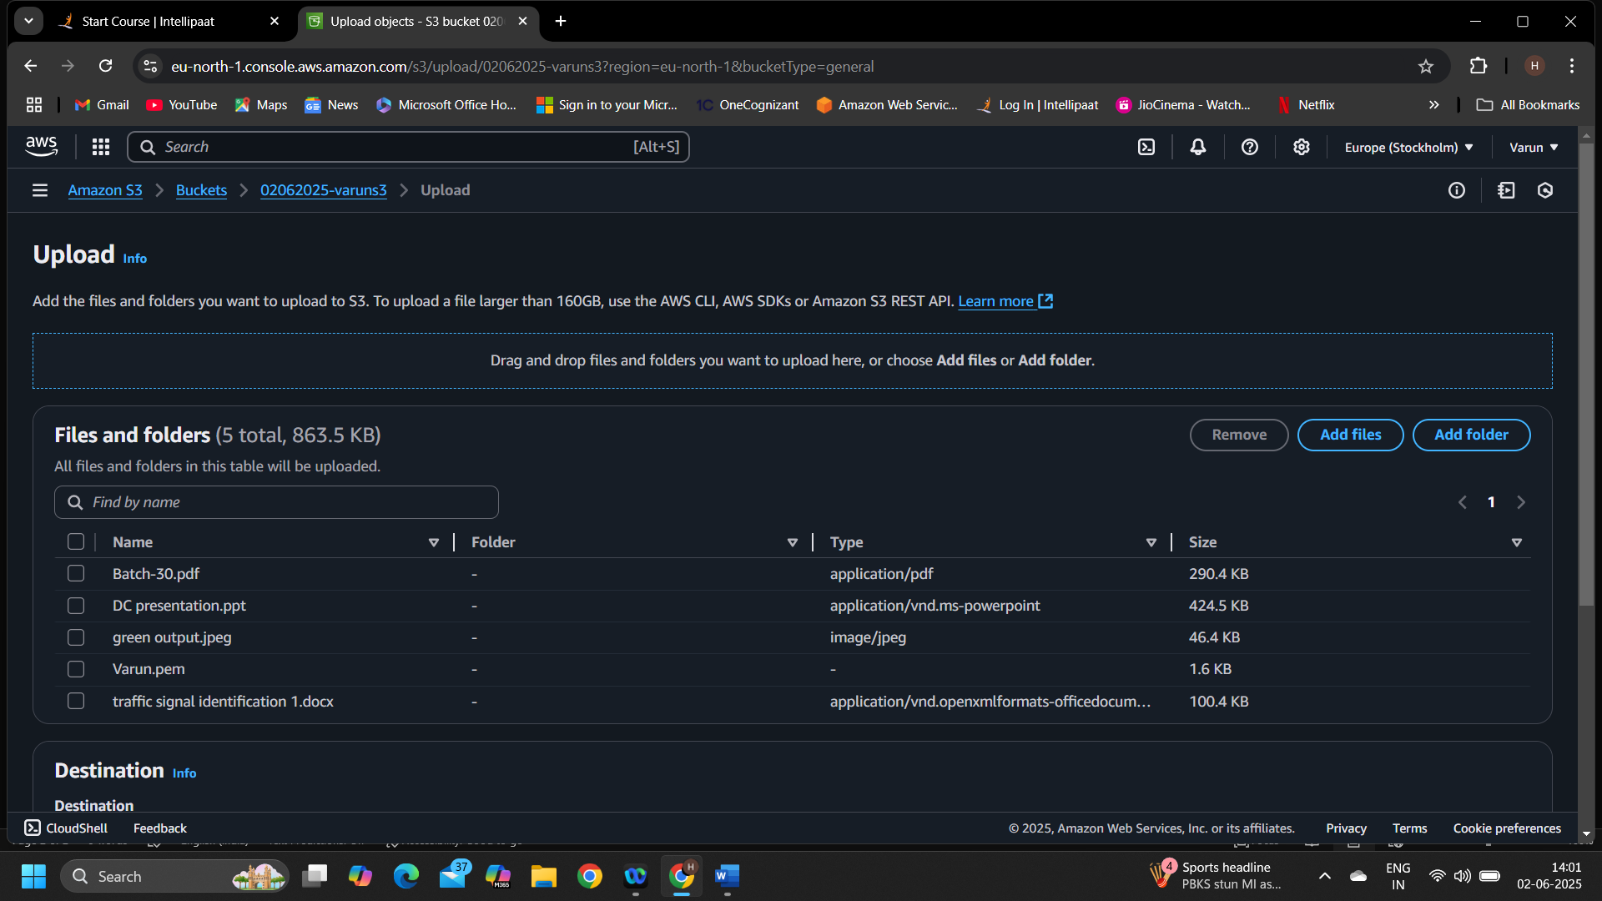

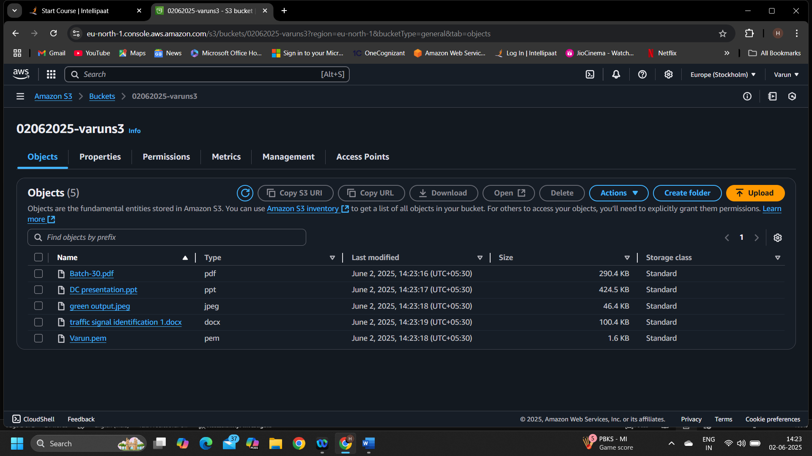

1. **S3 Bucket Versioning Assignment**
2. Enabling bucket versioning

1. Reuploading any 2 files to check the versioning

1. **S3 Website Hosting**
2. Uploading index.html and error.html files

1. Adding lifecycle rules for the bucket

